Instructions on how to execute and validate

**1.Prerequisites:**

* Ensure that you have Node.js (version 16 or above) and npm (Node Package Manager) installed on your computer. You can download and install Node.js from the official website: Node.js Downloads.

**2.Download or Clone the Repository:**

* React project is provided as part of a repository <https://github.com/Abhishekcec/product-demo.git> , download or clone the repository to your local machine.

OR

Download zip file provided in the mail

**3.Navigate to the Project Directory:**

* Using a terminal or command prompt, navigate to the directory containing the React project files.

**4.Install Dependencies:**

* Run the following command to install project dependencies specified in the package.json file:

npm install

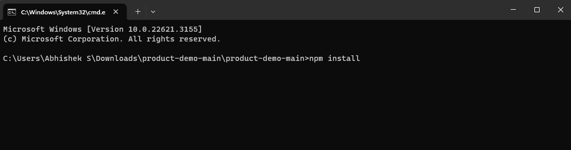

**5.Start the Development Server:**

* Once the dependencies are installed, start the development server using the following command:

npm start

**6.Access the Application:**

* After the development server has started successfully, you should see a message indicating the server is running. Open a web browser and navigate to the specified address (usually http://localhost:3000) to view the React application.

**Note:** Application is deployed in Github pages, it can be accessed by <https://abhishekcec.github.io/product-demo/>

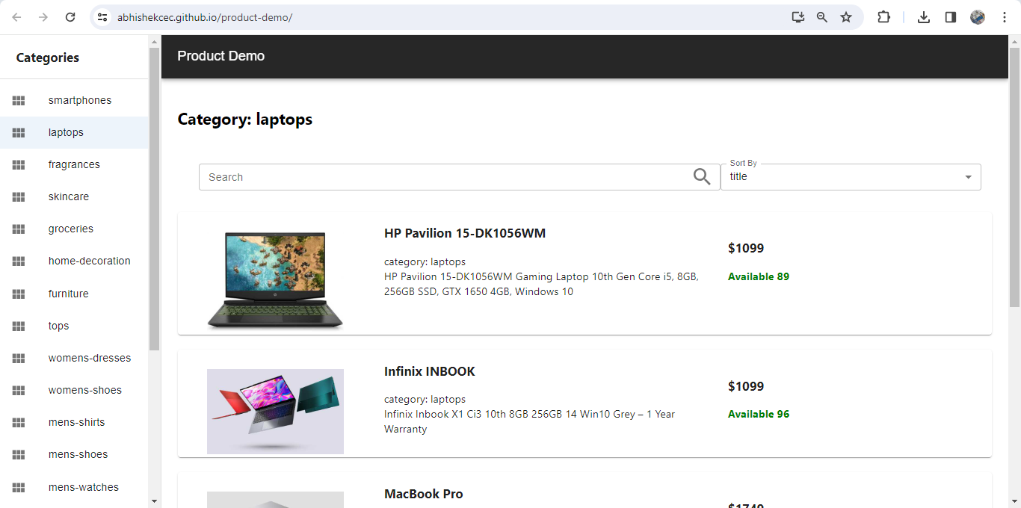

In Left sidebar all categories are present, which can be selected to filter products by category

There is option to search by title and sort by options as mentioned in the document